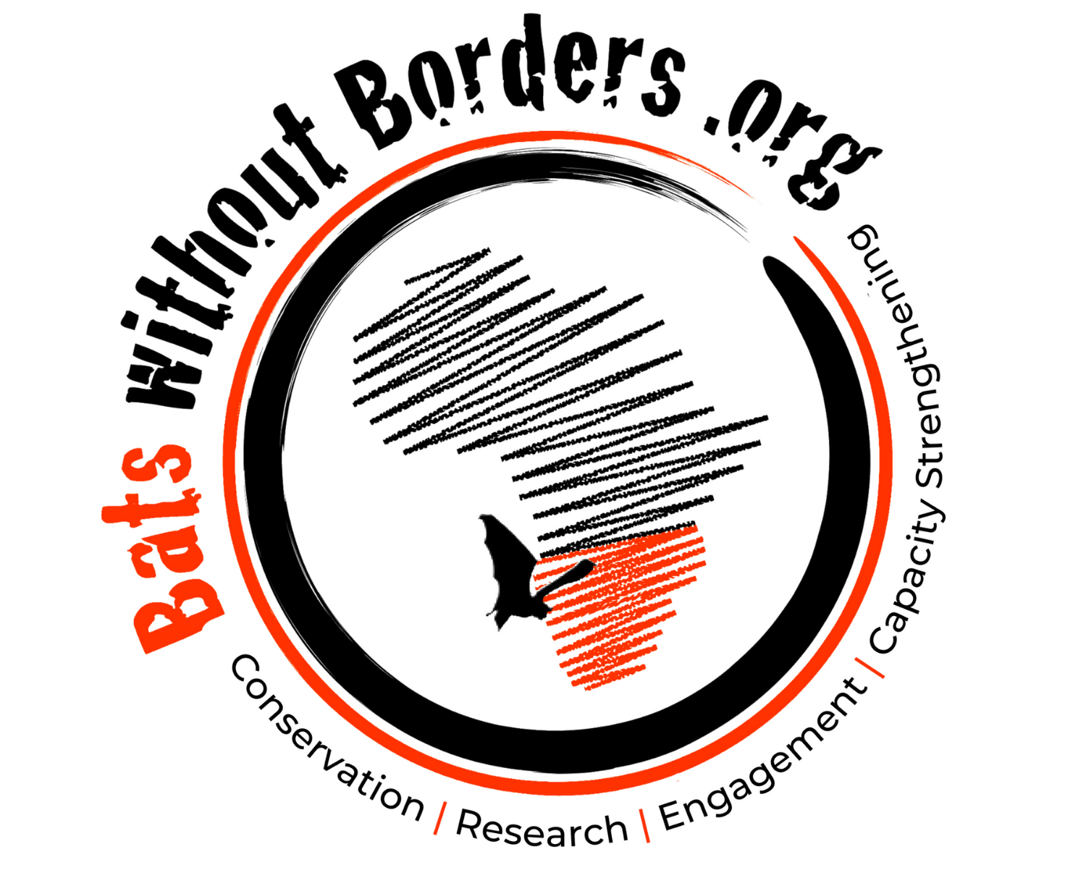
Equality and Diversity monitoring form
Date: February 2023

Bats without Borders is committed to promoting equality, diversity and inclusion for all, ensuring that no employee, intern or volunteer, or potential employee, intern or volunteer, receives less favourable treatment on the grounds of their sex, gender identity, race, ethnic or national origin, disability, sexual orientation, marital status, religion or belief, age, or any other personal characteristic. Diversity is viewed positively, in recognising that everyone is different, and valuing the unique contribution that everyone’s experience, knowledge and skills can make.
As part of our commitment to promoting fair procedures for recruitment and selection and monitoring our staff, intern and volunteer population, we ask all applicants to complete this Equality and Diversity monitoring form. You do not need to fill out this form but doing so assists us in monitoring who is applying for roles with us, and is solely used for monitoring purposes and to help us identify any barriers to diversity among our team.

This form will be separated from your application on receipt. It will not be seen by the interviewers and will not be used in any decision-making. We would be grateful if you would fill in this form and return it with your application. You are not obliged to answer all the questions but the more information you supply, the more effective our monitoring will be. All information supplied will be treated in the strictest confidence.
Thank you for your assistance.

Role title
Where did you see the vacancy?

Age
- 16 - 24 | - 25 - 44 | - 45 - 64 | - 65 - 74 | - 75+

Sex
How would you describe your sex?

- Female | - Male | - In another way | - Prefer not to say
If you prefer to use your own term, please specify here:

Gender
How do you describe your gender identity?

- Woman | Man | - Intersex
- Non-binary | - Prefer not to say
- If you prefer to use your own term, please specify here:

Religion or belief
Which group below do you most identify with?

- No religion | - Animism | - Buddhist
- Christian | - Hindu | - Muslim
- Other (please write in) |  | - Rather not say

Disability
Do you see yourself as having, defined as a physical or mental impairment, which has a substantial and long-term adverse effect on the ability to carry out normal day-to-day activities?

This may include dyslexia, autism, multiple sclerosis, blindness, partial sightedness, a long-term health condition and other examples.

Do you consider yourself to be disabled?

Yes | No | Don’t know | Prefer not to say

Ethnicity
How would you describe your ethnicity?

Sexual orientation
How would you describe your sexual orientation?

Bisexual | Gay or lesbian | Heterosexual or ‘straight’
If you describe your sexual orientation in another way, please write in: |  | Prefer not to say

Date:

Thank you for providing this information!
Please return together with your completed application to info@batswithoutborders.org

